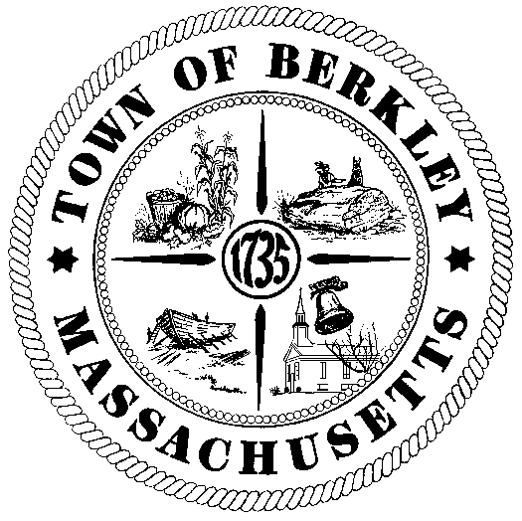

##### Town of Berkley

###### Massachusetts

**Offices of**

# **Board of Health**

**One North Main Street**

**Berkley, MA 02779**

Office Hours:

Monday, Tuesday & Wednesday

9:30 AM to 2:30 PM

Phone : 508-822-7828

Fax : 508-386-2100

Email : boardofhealth@berkleyma.us

**QUESTIONNAIRE FOR FOOD/RETAIL ESTABLISHMENT PERMITS/TEMPORARY PERMITS**

**(Questionnaire must be completely filled out & Checks should be made payable to the Town of Berkley)**

|  |
| --- |
| **Business Info:**  Name: Phone #  Address: _________________________________________________________________  Type of Business: _________________________Contact Person: ____________________  Days and Hours of Operation: Sun ___________ Mon ____________ Tues ___________  Wed ____________ Thurs ____________ Fri ____________ Sat ____________ |

|  |
| --- |
| **Owner’s Info:**  Name: Phone #  Address: E-Mail: |

|  |
| --- |
| **Insurances: (check all that apply and attach copies)**  Insurance Liability ⁫ Workers Comp ⁫ Affidavit ⁫ |

|  |
| --- |
| **Temporary Food Permit (1Day) $100.00 (Each additional day $75.00)**  **Licenses & Permits: (check all that apply and attach copies)**  Food ⁫ $125.00 Milk & Cream ⁫ $75.00 Tobacco ⁫ $125.00  Serve Safe Certification ⁫ Allergen Awareness Training Permit  Annual Potability Test ⁫ |

Manager’s Signature: Date:

**QUESTIONAIRE FOR FOOD SERVICE PERMITS/RENEWAL**

Is there parking available? Yes ⁫ No ⁫

Number of parking spaces available for customers

Number of parking spaces available for employees

Is there handicap parking and accessibility? Yes ⁫ No ⁫

How many?

⁫ List or include a menu of the type of meals to be sold: (Breakfast, Lunch, Dinner etc.)

Persons in Charge of Food Preparation:



List all Employees with Serve Safe Certification: (Include copies of certification)



List all wholesale food suppliers:



Will patrons be supplied with bottled water or water from an on-site well? _______________

**Please provide the following information regarding your establishment:**

How many employees? ___________ Open to the public? Yes ⁫ No ⁫

Please provide the following information: (please indicate actual #)

(10 seats, 4 tables, 12 booths, 8 counter seats, 5 employees per shift)

How many seats are available?

How many tables?

Are there booths and counter seating?

How many employees per shift?

Do you have a pest control plan? Yes ⁫ No ⁫

If yes: explain your pest control plan

Do you have a Septic Pumping Plan: Yes ⁫ No ⁫

If yes: has a copy of the plan been given to the BOH? Yes ⁫ No ⁫