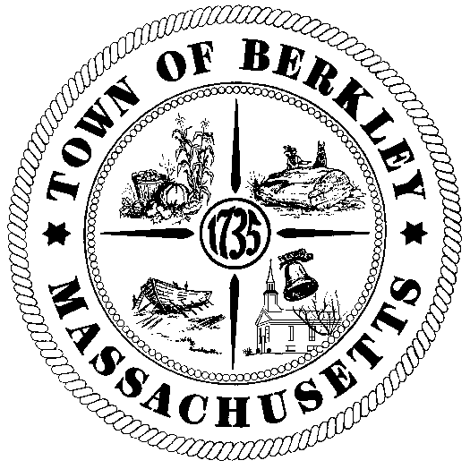
Received: 2/12/26 Time: 12:32pm
Posted: 2/12/26 Time: 1:11pm
H. Almy
Town Clerk
TOWN OF BERKLEY

MEETING NOTICE

Name of Board or Committee: Council on Aging

Date & Time of Meeting: February 19, 2026
Location of Meeting: Hearing Room, Town Hall

Krista Celia 02/12/26
Director, posting notice & date

AGENDA / LIST OF TOPICS
Review of matters, votes may be taken

- Call to order at 9:30 a.m.
- Announcement Regarding Meeting Being Video-taped.
- Acceptance of Prior Minutes: 12/18/2025 & 1/22/26
- Budget Report
  - Town Budget
  - Formula Grant
  - Donations – two accounts
- Event/Program Updates - Including but not limited to:
  - Mobile Market & Blood Pressure Clinic – Wednesday, February 25th at 10:00
  - Men’s Group – Wednesday, February 25th at 1:00
  - Winter Hat Project – Lucky Bunny – Thursday, February 26th at 10:00
  - CPR and Choking Education March 11th from 1:00 -2:30
  - Painting with Amy – Spring Painting – Thursday, March 12th at 2:45
  - Singo – Wednesday, March 18th at 12:30
  - SAVE Task Force Community Forum – Saturday, March 21st from 10:00 – 11:00
  - Glucose, Blood Pressure and Cholesterol Clinic – Wednesday, March 25th from 10:00 – 12:00
  - Bank Fraud Presentation – Wednesday, April 15th at 1:00
  - Upcoming programs dates TBA. (Watercolor, Jewelry Making, Planter)
- Friends of COA Report
- Public Input
- Notice of next meeting date
- Adjourn

This agenda is subject to change(s) not anticipated by the Chairman or Director 48 hours in advance.

