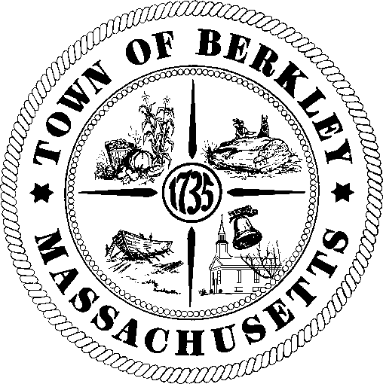
TOWN OF BERKLEY
MEETING NOTICE

(PLEASE PRINT OR TYPE LEGIBLY)
Name of Board or Committee: Date & Time of Meeting:

Location of Meeting:

Berkley Public Library Board of Trustees: Tuesday, February 10th at 7:15 PM

Berkley Public Library, 2 North Main Street, Berkley, MA

Emily Taylor, Secretary 2.5.2026
Received 2-5-26 9:42am
Posted 2-6-26 11:29am
H. Almy Town Clerk

Clerk/Board Member posting notice & date
Cancelled or postponed to:

Clerk/Board Member cancelling/postponing meeting:
AGENDA / LIST OF TOPICS

- Call to order
- Set March meeting date
- Review minutes of January 13th meeting
- Children’s Librarian’s report
- Director’s report
  - Correspondence
  - FY2027 Budget Conversation, votes may be taken
  - Discussion regarding requests from the SAVE Task Force; votes may be taken
- Friends of the Library Update
- Update of progress of the building project
  - Recap of recent building committee meetings
  - Next Steps
- Past Business
  - Discuss/ approve letter of thanks to the Berkley Highway Department; votes may be taken
  - Discuss/ approve letter of thanks to the Carnegie Foundation and a press release for the donation; votes may be taken
  - Policy for 2nd Reading – Cellphone Use Policy; votes may be taken
  - Policy for 1st Reading – Closure of the Library; votes may be taken
- Public Input
- Any items unanticipated by the chair within 48 hours of the meeting
- Adjourn

